**1. In the below elements which of them are values or an expression? eg:- values can be integer or string and expressions will be mathematical operators.**

**\***

**'hello'**

**-87.8**

**-**

**/**

**6**

Ans.) Expression are as follows:

1)*

2) –

3)/

4) +

**2. What is the difference between string and variable?**

Ans.)

|  |  |
| --- | --- |
| **String** | **Variable** |
| String is a data type that represents a sequence of characters under the quotation marks | Variable is a named reference to a value in Python. |
| String is a specific type of data, representing textual information | Variable is a container that can hold various types of data, including strings. |

3. **Describe three different data types.**

Ans.) 1. **Integer (int):** The integer data type represents whole numbers without any fractional or decimal parts. Integers can be positive or negative, or zero. They are used for counting, indexing, and performing arithmetic operations.

2. **String (str):** Strings are used to represent textual data. They are sequences of characters enclosed in single quotes ('') or double quotes (""). String can contain letters, numbers, symbols, and spaces. They are immutable.

3. **Boolean (bool):** Boolean values represent two states: True or False. They are used in logical operations, comparisons, and conditional statements. Booleans are useful for decision-making and control flow in programs.

4. **What is an expression made up of? What do all expressions do?**

Ans.) Expression is a combination of values, variables, operators, and function calls that produces a result. Expressions are used to perform computations, manipulate data, and make decisions within a program.

5**. This assignment statements, like spam = 10. What is the difference between an expression and a statement?**

**Ans.)**

|  |  |
| --- | --- |
| **Expression** | **Statement** |
| An expression is a combination of values, variables, operators, and function calls that can be evaluated to produce a single value. | A statement is a line of code that performs an action. It represents a complete instruction or command in a program. |
| An expression in Python can contain identifiers, operators, and operands. | Statements can include assignments, function calls, control flow structures. |

6. **After running the following code, what does the variable bacon contain?**

**bacon = 22**

**bacon + 1**

7. **What should the values of the following two terms be?**

**'spam' + 'spamspam'**

**'spam' * 3**

Ans.)

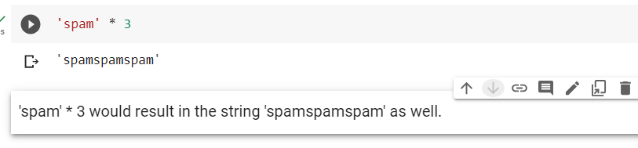

8. **Why is eggs a valid variable name while 100 is invalid?**

Ans.) The following are rules for naming a variable in python:

* Variable can not start with number(0-9). E.g.)3_idiots
* Variables are case-sensitive. Eg.) Ram is different than ram.
* Variable can contain number, alphabet, & underscore.
* They cannot contain spaces or other special characters.

This is why eggs is a valid variable name. It starts with a letter ('e') and does not violate any other rules.

On the other hand, 100 is considered an invalid variable name because it violates the first rule. It starts with a number ('1') instead of a letter or underscore.

9. **What three functions can be used to get the integer, floating-point number, or string version of a value?**

**Ans.)** 1. **int()** - This function is used to convert a value to an integer. It takes a parameter and attempts to convert it into an integer.

2. **float()** - This function is used to convert a value to a floating-point number. It takes a parameter and tries to convert it into a float.

3. **str() -** This function is used to convert a value to a string. It takes a parameter and returns its string representation.

10. **Why does this expression cause an error? How can you fix it?**

**'I have eaten ' + 99 + ' burritos.'**

Ans.) 